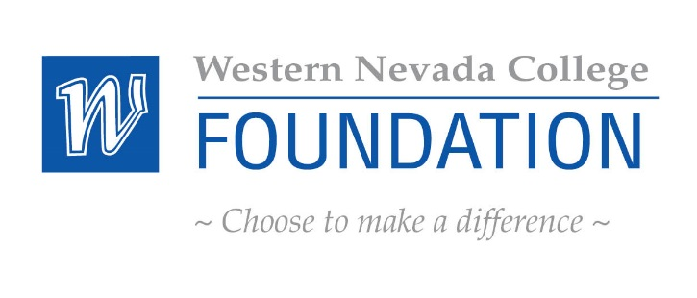

Finance Subcommittee Meeting Agenda
January 21, 2015
Western Nevada College Foundation Office
- WELCOME
- PUBLIC COMMENT - Public comment will be taken during this agenda item. No action will be taken on a matter raised under this item until the matter is included on an agenda as an item on which action may be taken. The Chair of the Finance Committee may place reasonable limitations as to the amount of time individuals may address the Committee. The Chair may elect to allow public comment on a specific agenda item when that item is being considered.
III. FINANCE AGENDA
NOTE: Below is an agenda of all items scheduled to be considered. Notification is hereby provided that items on the agenda may be taken out of the order presented, two or more agenda items may be combined for consideration, and an agenda item may be removed from the agenda or discussion relating to an item on the agenda may be delayed at any time. Reasonable efforts will be made to assist and accommodate physically handicapped persons desiring to attend the meeting. Please call the number listed in advance so that arrangements for attendance may be made ATTACHMENT
A. Approve Minutes from September 24, 2014 Possible Action Item 1
B. Consolidation of smaller Schwab accounts into one investment pool Discussion 2
C. Investment strategy for BECK Fund Possible Action Item 3
D. Standardizing the investment strategy, endowments, investment policy Possible Action Item 4
E. Review/Approve Finances September 2014 –December 2014 Possible Action Item 5
F. Review/Approve Charles Schwab Investment Portfolio Possible Action Item 6

- NEW BUSINESS
- ANNOUNCEMENTS/PUBLIC COMMENT
- ADJOURNMENT
  - NEXT MEETING: Wednesday March 11, 2015 8:00 a.m. WNC PRESIDENTS BOARD ROOM

