WNC Policy 7-3-2: Bank Deposits
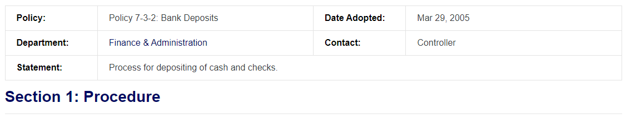
- Controller’s office and rural campus cashiering staff will deposition checks daily via the remote deposit process.
- Controller’s office will deposit cash weekly. Additional deposits may be made as needed based on volume and amount on hand.
- As directed by the Controller’s office, all other departments are required to deliver their deposits to the Controller’s office every three days unless the total exceeds $500. For amounts of $500 or more, the deposit shall be daily.

Revised: 2/14/2022 - CL

