WNC Policy 7-5-3: Late Registration Fee
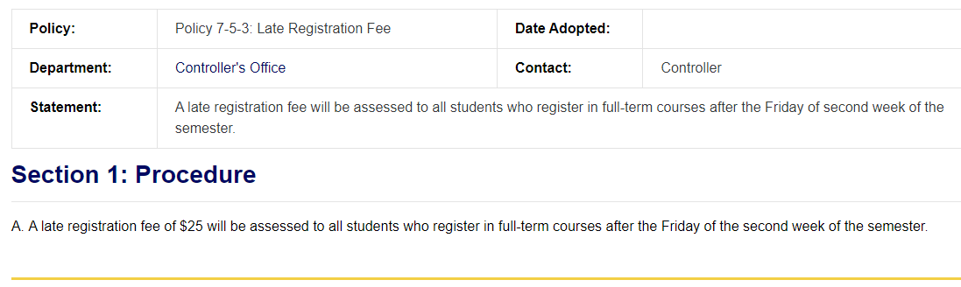
Reviewed: 2/14/2022 CL, CD
Revised: 3/15/2022 CL, DH
Statement: A late registration fee will be assessed to all students who register in full-term courses after the Friday of the second week of the semester, with the exception of open entry classes. This fee may also be charged for students who register late in short-term classes.

- A late registration fee of $25 will be assessed to all students who register in full-term courses after the Friday of the second week of the semester, with the exception of open entry classes. This fee may also be charged for students who register late in short-term classes.

